Linear Algebra
Part: 1

Suggestion
Bold blue = important words / key terms.
Purple bold = notations, symbols and section labels.
Green italic = references (dataset names, algorithms, movie examples).
Red bold and the bordered boxes = formulae and equations.
Everything else is the original explanation from the notebook, kept as written. Extra explanations, corrections and cut-off text are only written under the Suggestion box at the end of each page.

Notebook page 1

1) What are vectors?
Vectors are points on n-dimension space.
For example:
i) A point (4,3) is lying on a 2-D space, then vector is [4,3]; 4 being x-component and 3 being the y-component.
ii) A point (3,4,5) lying on a 3-D space, then vector is [3,4,5]; 3 being x component, 4 and 5 being y-component and z-component respectively.
n-dimension vector:
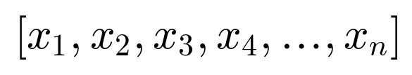

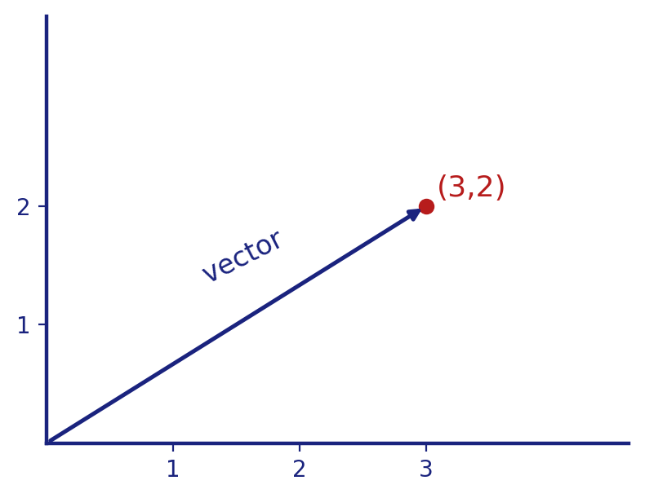

Suggestion
- A vector is just an ordered list of numbers. The graph shows the vector [3,2]: an arrow that starts at the origin and ends at the point (3,2). Each number is one component (one coordinate).

2) Vectors from machine learning's view point :-
⇒ Consider iris dataset. See the sample below. We're having 150 datapoints.
SL | SW | PL | PW | specie
5.2 | 2.1 | 7.2 | 9.7 | Versicolor
3.1 | 4.2 | 7 | 6.5 | setosa
⋮ | ⋮ | ⋮ | ⋮ | ⋮

Notebook page 2
Each data point is fed into the model in the form of a vector.
Feature vectors
v1 = [5.2, 2.1, 7.2, 9.7] → Model —Prediction→ Setosa
v2 = [3.1, 4.2, 7, 6.5] → Model —Prediction→ Versicolor
We're having 150 flowers / datapoints. So we'll have 150 vectors in total representing each datapoint.
⇒ Example 2: Movie Recommendation System.
Suppose we've 2 columns, movie and summary. Summary is the story of the movie in short. We encode it first and then we plot the vectors into an n-dimension space.
Then for recommendation, we recommend those vectors which are closer.
For example: Suppose the movie is Yaarana and we wanna recommend 3 movies; we'll select the 3 closest vectors to Yaarana's vector.

Suggestion
- SL, SW, PL, PW mean Sepal Length, Sepal Width, Petal Length and Petal Width. specie is the flower type (the target/label).
- In the table, each row is one flower, so each row becomes one vector such as [5.2, 2.1, 7.2, 9.7] (4 numbers = a 4-dimensional vector). We cannot draw 4-D, but the maths works the same way.
- The numbers in the sample table are only examples. In the real Iris dataset the values are smaller (for example, petal width is never above 2.5).
- A feature vector is the list of input values (features) of one data point. Here v1 and v2 are the inputs and the model predicts the flower type.
- Check: in the Iris table (topic 2) the first row (5.2, 2.1, 7.2, 9.7) was labelled Versicolor and the second row was setosa, but here v1 predicts Setosa and v2 predicts Versicolor. Please make the two pages match (swap the labels on one of the pages).
- Encode means changing text into numbers. For the movie summary this is done with methods such as TF-IDF or word/sentence embeddings. After encoding, each movie is one vector.
- "Closer" is measured with distance (topics 4 and 5, Euclidean distance) or with angle (cosine similarity, topic 9).

3) Row and Column vector :-
• Row vector x = [2, 4, 6, 8, 10] (1,5)
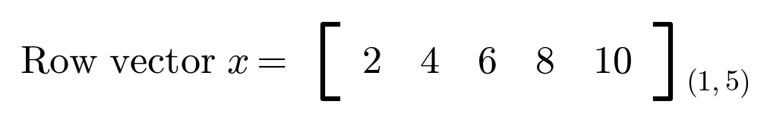
• Column vector y =
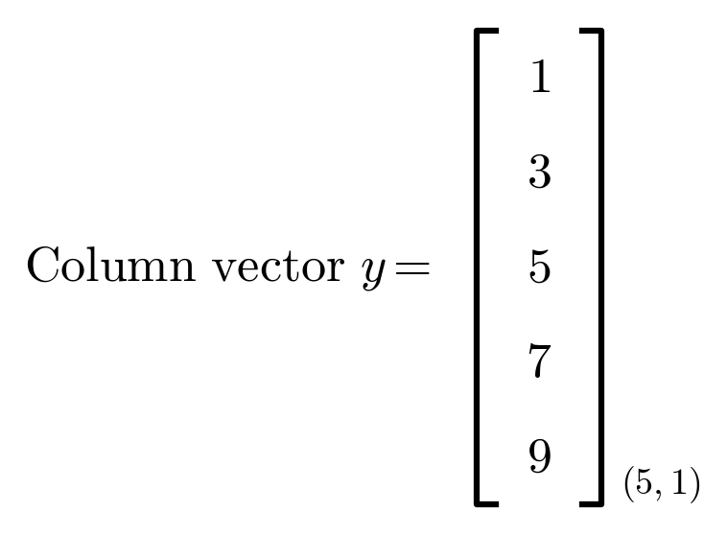

Suggestion
- Shape is written as (rows, columns): the row vector is (1,5) = 1 row and 5 columns; the column vector is (5,1) = 5 rows and 1 column.

Notebook page 3

4) Distance from origin :-
2-d space  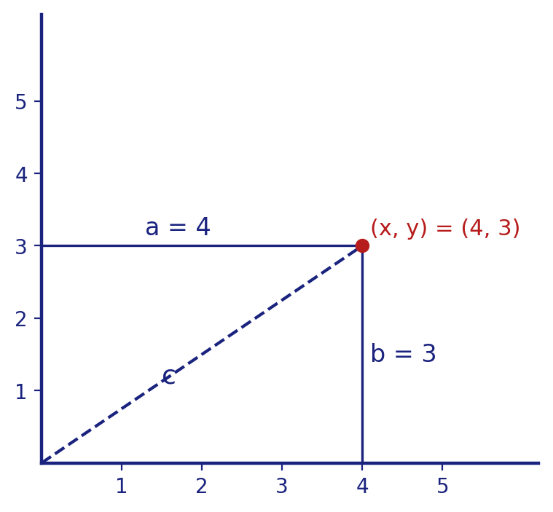 | 3-d space  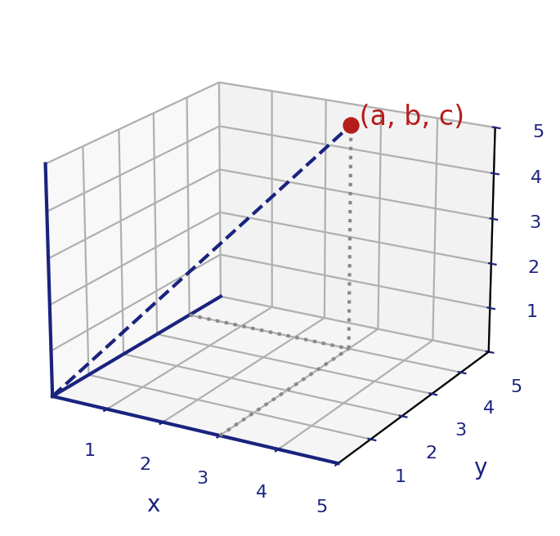

Pythagoras Theorem.
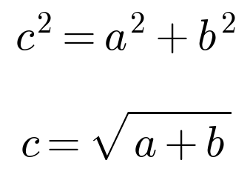

In 3-d space:
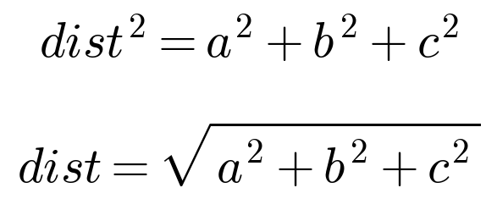

Distance in n-dimension:

Note: Distance from the origin is also known as Magnitude of the vector.

Suggestion
- In the 2-D Pythagoras formula the notebook shows c = √(a + b). The squares are missing. The correct formula is c = √(a2 + b2). Check with the graph: a=4, b=3 gives c = √(16 + 9) = √25 = 5.
- The magnitude of a vector is written ‖A‖. For A = [4, 3], ‖A‖ = 5. Every extra dimension just adds one more squared term under the root (as in the 3-d and n-d formulas).

5) Euclidean distance between two points:
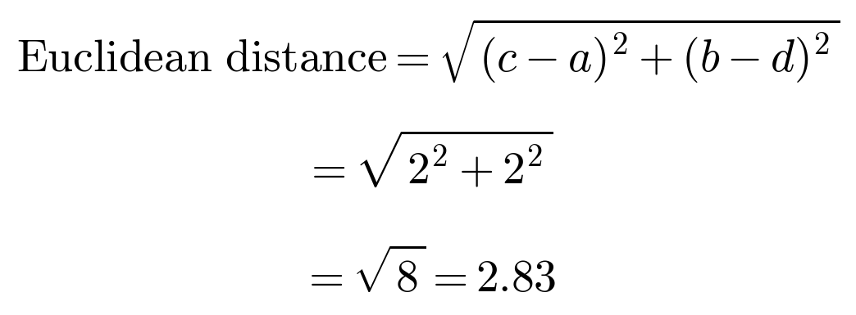

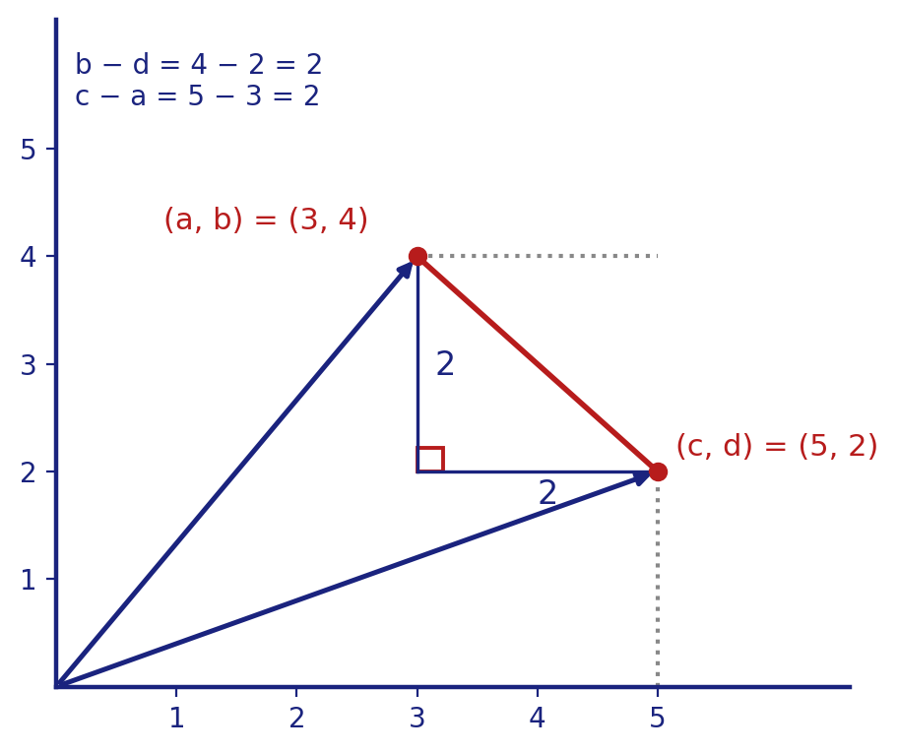
Notebook page 4

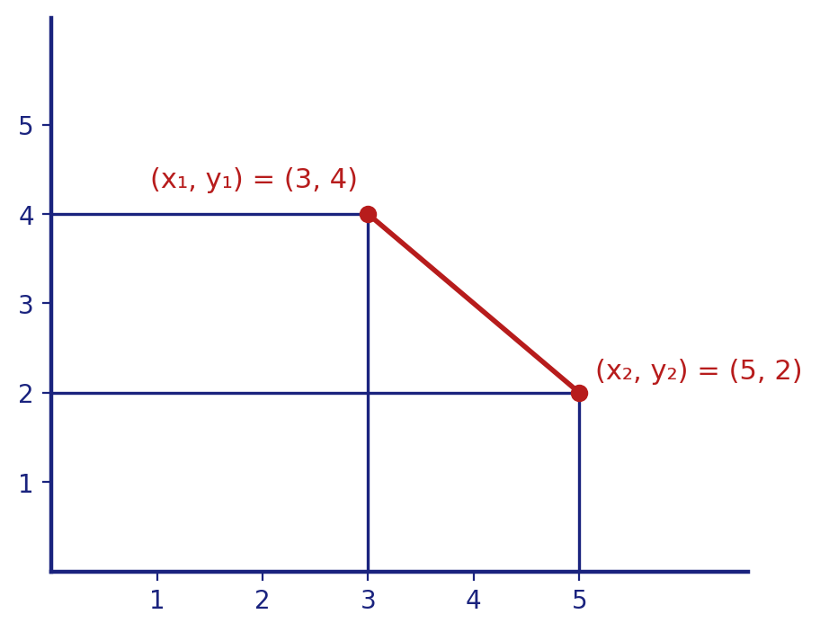
→ In 3d-space, and nD:
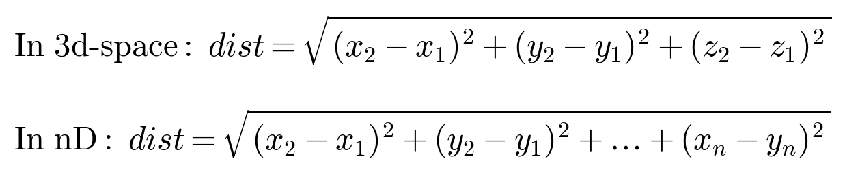

⇒ Euclidean distance in Machine Learning:
• In Machine learning, there're various algorithms using Euclidean distance.
• One of the most famous is K-Nearest Neighbors.
Suppose we've 2 input columns (2-D data) and one target; Sepal length, Petal length and specie.
– We'll plot vectors of each data point in a 2-D space.
– Now when we'll get a new data point for prediction, we'll calculate the distance of this new data point with all the datapoints.
– We'll select that vector's target whose distance is the shortest.

Suggestion
- Euclidean distance between two points is the straight-line distance. It is the magnitude of the difference vector: ‖P − Q‖. In the example the two legs of the triangle are both 2, so distance = √(4+4) = √8 ≈ 2.83.
- The original graph labels: (a,b) = (3,4) and (c,d) = (5,2); so c − a = 5 − 3 = 2 and b − d = 4 − 2 = 2.
- In the 2-d formula the handwriting looks like (y2 − y1)2. It should be (y2 − y1)2, the same pattern as the x part.
- In the nD formula the last term is written (xn − yn)2. To keep one notation it should be (xn2 − xn1)2, or simply write the two points as P = (p1,…,pn) and Q = (q1,…,qn) and use √Σ(qi − pi)2.
- K-Nearest Neighbors (KNN) in short: find the K closest points to the new point and take the most common class among them. The notes describe K = 1 (only the single nearest point).
- Tip: features should be on a similar scale (for example with standard scaling) before using distance, otherwise the feature with the big numbers dominates the distance.

Notebook page 5

6) Scalar addition / subtraction (shifting)
– v1 = [2, 8, 4, 9] + 3 (scalar addition) = [5, 11, 7, 12]
– v2 = [3, 4, 9, 12, 14] − 2 (scalar subtraction) = [1, 2, 7, 10, 12]
⇒ Where is this used in Machine Learning?
– It is used in mean centering.
– If we plot datapoints before and after deducting mean, before deduction we will get plot like A and after deduction we will get plot like B.
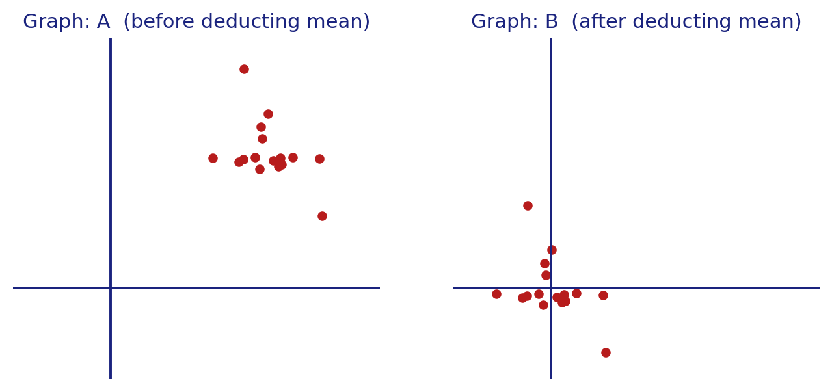
⇒ Some algorithms where mean centering is used are: 1) PCA 2) Linear Regression 3) Gradient based optimizations 4) Clustering algo 5) Regularization

Suggestion
- In scalar addition/subtraction the same number is added to (or subtracted from) every component. The shape of the data does not change; the whole cloud of points just slides.
- Mean centering means x' = x − mean. After this the mean of the data is at the origin (graph B). Mean centering needs the mean subtracted from each feature (column) separately.
- In the notebook the section numbers 5) and 6) are corrected to 6) and 7); this document follows the corrected numbers.

7) Dot product:
When we multiply a vector with another vector, it is called a 'Dot Product'. And the result is a scalar.
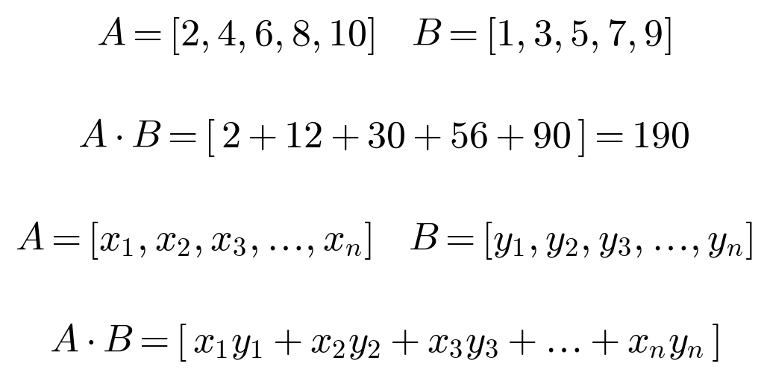

Notebook page 6
Note: When we work with vectors and if not specified, by default we consider it as a column vector.
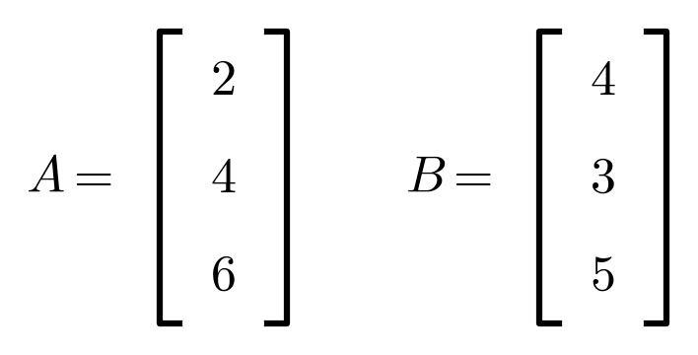
For A.B, we do i) ATB or A.BT
⇒ Rules of Dot product:-
1) Cumutative: A.B = B.A
2) Distributive: A(B+C) = AB + AC
⇒ Uses of dot product:
1) Compare similarity between two vectors. How? We'll learn later.
2) Projection: We've vectors A and B, we can find the projection of A and B using dot product. How? We'll learn later.
3) Perform matrix multiplication.

⇒ Uses in Machine Learning
1) Movie Recommender system:
– We plot vector for each data points in a graph
– Then when we want 3 recommendation for movie Sholay, we find similarity score of Sholay's vector with each other vector and return top 3 with highest similarity score.
– We use cosine similarity which we'll learn later
Notebook page 7
2) Deep Learning: In deep learning, we perform various matrix multiplications which simply means we require dot product.
– Means deep learning is totally relying on dot product.

Suggestion
- The dot product gives one single number, so the square brackets in A·B = [2+12+30+56+90] = 190 are not needed; write A·B = 190. Both vectors must have the same length.
- Worked example for A = [2, 4, 6] and B = [4, 3, 5] (both columns): ATB = 2×4 + 4×3 + 6×5 = 8 + 12 + 30 = 50. Shape check: (1×3)(3×1) = (1×1), a single number.
- The second option A.BT is not correct for column vectors: (3×1)(1×3) gives a 3×3 matrix, not a number. The two correct ways are ATB or BTA.
- Spelling: "Cumutative" should be Commutative (order does not matter: A·B = B·A).
- Distributive rule in words: multiplying A with (B + C) is the same as multiplying A with B and A with C, then adding.

8) Angle between two vectors.
– A.B = ‖A‖ ‖B‖ cos θ
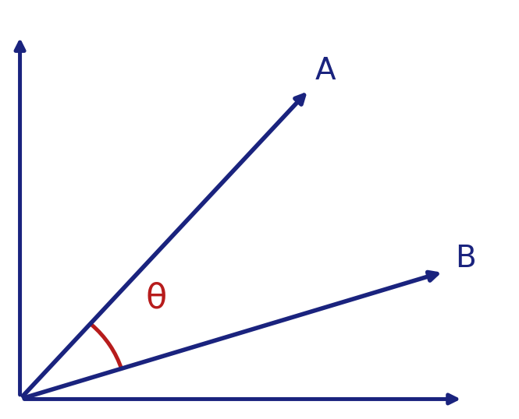
– Using dot product, we can conclude many features of vectors.
– For eg: If A and B are non-zero vector (means magnitude ≠ 0) and it's given that A.B = 0. In this case, we can conclude that ‖A‖ ‖B‖ cos θ = 0 and θ = 90° and A ⊥ B. This suggests that A and B are dis-similar vectors.
– Using dot product, we can calculate angle between two vectors. Suppose components of A = [a1, a2, a3, …, an] and B = [b1, b2, b3, …, bn]
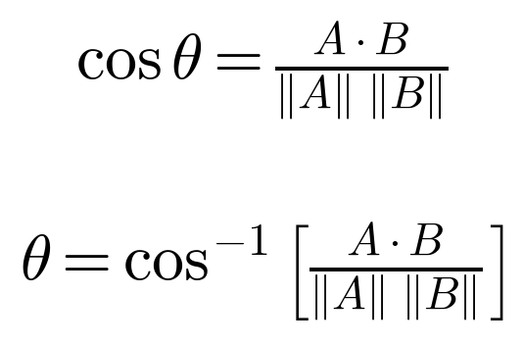

Suggestion
- ‖A‖ is the magnitude (length) of A: ‖A‖ = √(a12 + a22 + … + an2).
- Why cos θ = 0? The magnitudes are not zero, so the only way the product can be 0 is cos θ = 0, which means θ = 90°. Vectors at 90° are called perpendicular (or orthogonal) and their dot product is 0.
- Example: A = [1, 0] and B = [0, 1]. A·B = 1×0 + 0×1 = 0, so the angle is 90°.
- The angle formula comes from rearranging A·B = ‖A‖‖B‖cos θ: divide both sides by ‖A‖‖B‖ to get cos θ, then use cos−1 to get θ.

Notebook page 8

9) Cosine similarity:
Used to measure similarity of two vectors.
– 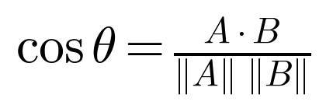 ; means cos of angle between A and B.
– Cosine similarity gives result between −1 and 1
– If θ = 0, it means the vectors are of same direction and are totally similar.
– If cosine similarity = (−1), means vectors are totally in opposite direction and hence θ = 180°.
– If cosine similarity = 0, means θ = 90° and hence there's no similarity.
– If cosine similarity is between 0-1, θ = acute angle and similarity increases from 0-1.
– If cosine similarity is between −1-0, θ = obtuse angle.
– We can use cosine similarity for Movie Recommendation System.
Note: In last pages, we've learnt

Suggestion
- The formula on this page is written cos θ = AB / (‖A‖‖B‖). The top of the fraction should be the dot product A·B, not a plain product.
cos θ (similarity) | Angle θ | Meaning
1 | 0° | same direction, totally similar
between 0 and 1 | acute (0° to 90°) | similar; more similar as it nears 1
0 | 90° | no similarity
between −1 and 0 | obtuse (90° to 180°) | opposite tendency
−1 | 180° | exactly opposite direction

- The last line is unfinished. A suggested ending: "Note: In last pages, we've learnt vectors, distance from origin (magnitude), Euclidean distance, scalar shifting, dot product and the angle between two vectors. Cosine similarity is built from these ideas."
- Cosine similarity looks only at direction, not length, so it is popular for text and movie recommendations.

Notebook page 9

Now we'll learn the eqn of hyperplane but before that, let's learn few things.
Calculate regression line for below given data.
x | y | x2 | y2 | xy
0 | 5 | 0 | 25 | 0
1 | 3 | 1 | 9 | 3
2 | 2 | 4 | 4 | 4
3 | 0 | 9 | 0 | 0
4 | -1 | 16 | 1 | -4
5 | -3 | 25 | 9 | -15
6 | -5 | 36 | 25 | -30
7 | -6 | 49 | 36 | -42
8 | -8 | 64 | 64 | -64
9 | -9 | 81 | 81 | -81
45 | −22 | 285 | 254 | −229

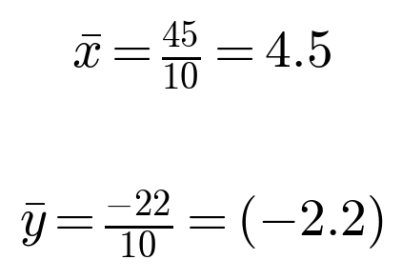

⇒ y = mx + c; where
i) m = (nΣxy − (Σx)(Σy)) / (nΣx2 − (Σx)2)
ii) c = ȳ − m x̄
⇒ Slope m:
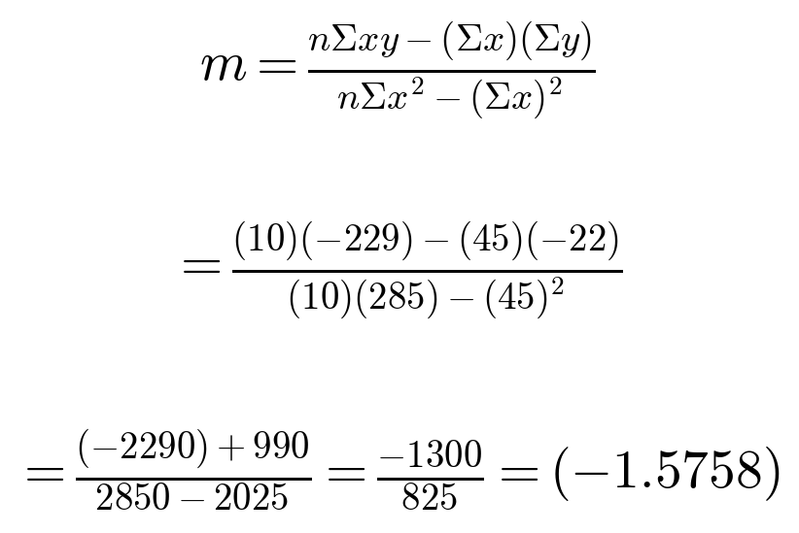

⇒ Intercept c:
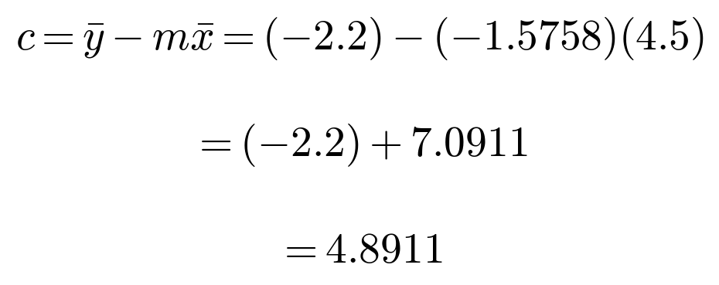

Notebook page 10
∴ Regression line:
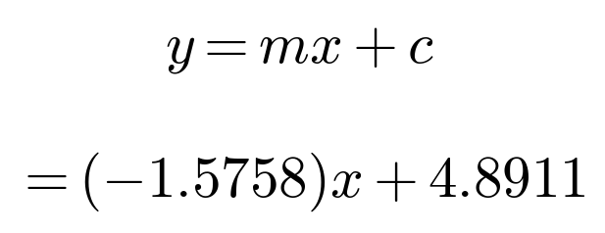

⇒ Convert regression eqn in Ax + By + C = 0 form.
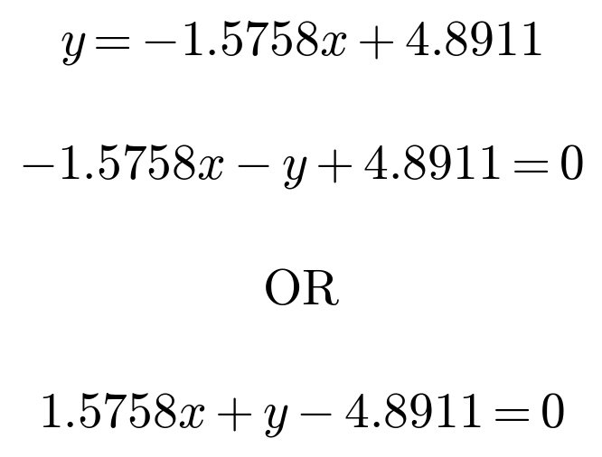

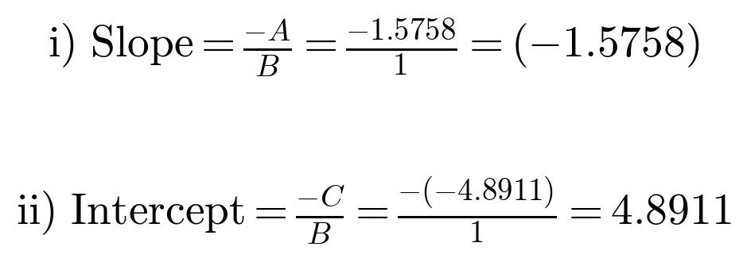

Note: Both above equations are same. We'll get same slope and intercept of both the equations.
– If we multiply eqn 1 with (−1) we'll get eqn 2.

Suggestion
- Here n = 10 (there are 10 rows). Σx = 45, Σy = −22, Σx2 = 285, Σxy = −229. The column y2 (total 254) is not needed for the slope and intercept.
- Small rounding note: if we keep more digits, m = −1300/825 = −1.575757… and c = −2.2 + 1.575757… × 4.5 = 4.8909. The notebook rounds m to −1.5758 first, so it gets 7.0911 and 4.8911. Both are fine; the difference is only rounding.
- This method is called least squares: it finds the line y = mx + c that keeps the total squared distance from the points as small as possible.
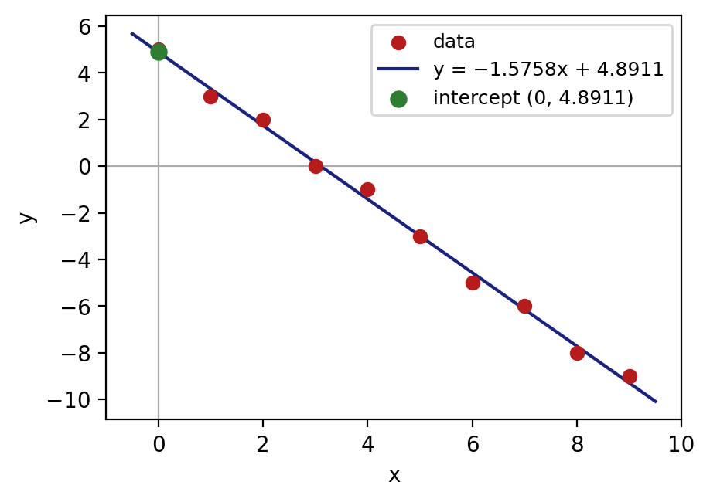
The data points and the regression line y = −1.5758x + 4.8911 (added to help understand the result).
- The cut sentence should end like this: "If we multiply eqn 1 with (−1) we'll get eqn 2." That is, −1.5758x − y + 4.8911 = 0 becomes 1.5758x + y − 4.8911 = 0. Multiplying all terms by −1 does not change the line.
- Check with the first form: A = −1.5758 and B = −1, so slope = −A/B = −(−1.5758)/(−1) = −1.5758. Same answer as the second form (A = 1.5758, B = 1).

★ What is slope and intercept ?
1) Slope:
→ Consider this data. x = [0, 1, 2, 3, 4, 5] and y = [4, 2, 0, (−2), −4, −6]
→ Slope determines 'rate of change'
→ Here, in the above data slope is (−2)
→ Which simply means if x increases by 1, y decreases by 2.
x↑1 → y↓2.
Notebook page 11
→ In regression line, the effect of slope is that it tilts the line.
Visual meaning:
• slope = 2 → Steep uphill
• slope = (−2) → Steep downhill
• slope = 0 → Flat road
We got slope (−1.5758), means x↑1, y↓(−1.5758)

Why is the slope useful? It tells us trend / relationship between x and y.
→ Remember, slope = rate of change in y, when x changes.

2) Intercept:
→ Intercept determines the point where the regression line cuts y-axis.
→ This simply means, what is y-coordinate when x = 0.
→ That is the point where line cuts y-axis.
→ That point is the starting point.
→ In our previous data, intercept was 4.8911.
Means at x = 0, y = 4.8911.
→ So intercept = 4.8911 and starting point = (0, 4.8911)

Real life meaning of intercept.
→ It tells us the starting value.
For example:
1) Salary growth → Intercept → Starting salary.
2) Distance → Intercept → Initial position.
3) Bank balance → Intercept → Initial balance.
Notebook page 12
y = mx + c → Final value = slope × x + intercept
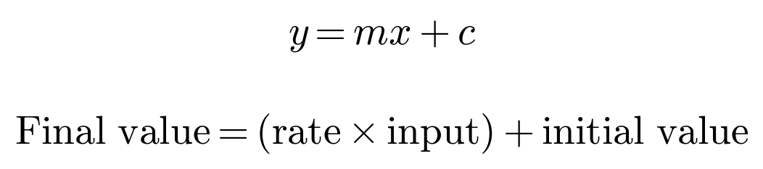

We know that the slope shows rate of change but why do we need intercept?
→ Because a slope alone doesn't define a line.
→ Slope tells us the rate of change but what about the starting point?
→ For example:
i) y = -2x + 4
ii) y = −2x + 10 ⟶ All eqn have same slope (−2) but different line positions if we plot.
iii) y = −2x − 3
So what does an intercept do?
→ Intercept fixes the position of the line.
→ Slope tilts the line whereas intercept moves line up and down.
→ Specifically it tells us where the line cuts y-axis when x = 0.

Real life intuition: y = mx + c
1) Think of salary growth, m shows yearly increment and c shows the starting salary. Without c we know the growth rate but not where we started.
2) Distance: m = speed and c = starting position. Without c we won't know from where did we start.
Notebook page 13
⇒ Overview:
• Slope = rate of change in y when x changes by 1 unit.
• It tilts the regression line.
• Intercept = starting point. Shows from where we started.
• It moves the line upwards and downwards.

Suggestion
- How to see the slope in the data: slope = change in y ÷ change in x = (2 − 4) / (1 − 0) = −2. Every step of 1 in x lowers y by 2.
- "y↓(−1.5758)" has a double negative. Better to say: when x increases by 1, y changes by −1.5758, that is, y decreases by 1.5758.
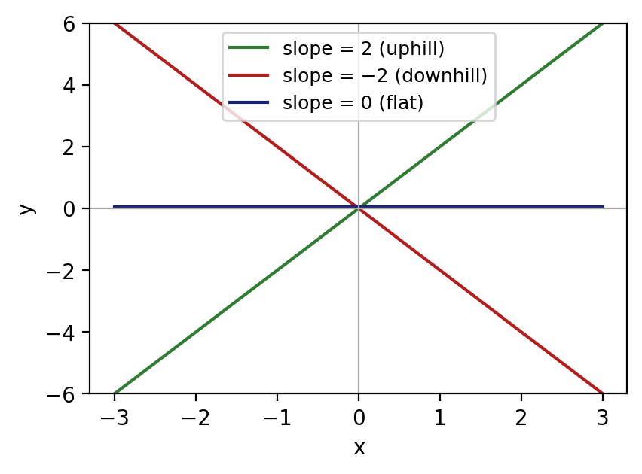
Slope = 2 goes up, slope = −2 goes down, slope = 0 is flat (added for a clear picture).
- Slope alone cannot fix a line. The next part explains why we also need the intercept.
- In the list of three equations the notebook says all have slope (−2), but y = 2x + 4 has slope +2. It was probably meant to be y = −2x + 4. The graph below uses that corrected form.
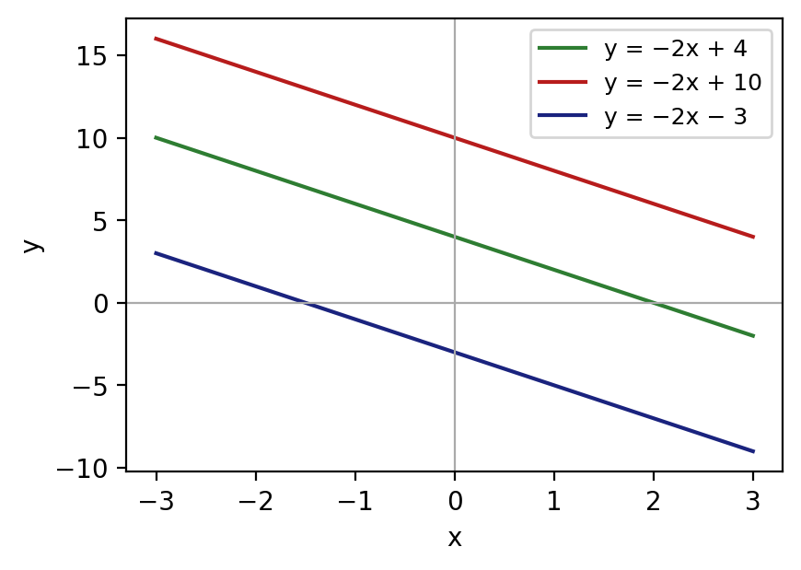
Same slope (−2), different intercepts 4, 10 and −3: the lines are parallel and only their up/down position changes.
- Small labels above y = mx + c on this page: Final value = (rate × input) + initial value.

★ Equation of a hyperplane.
Now our main topic starts. Consider eqn. y = mx + c.
General eqn:
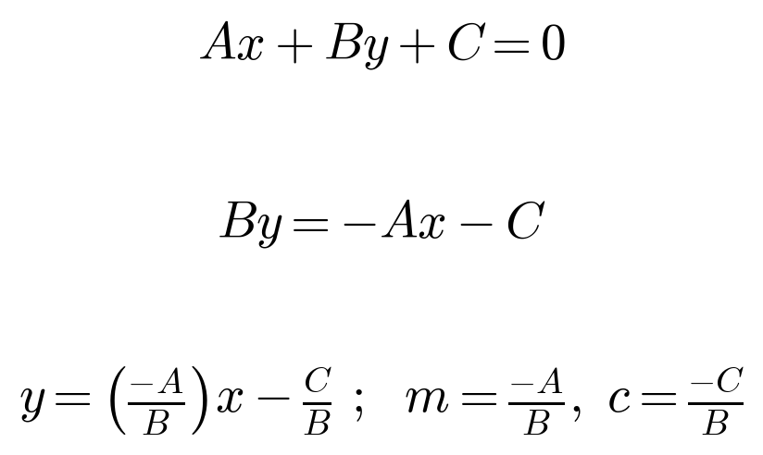

Slope (m) = −A/B, Intercept (c) = −C/B
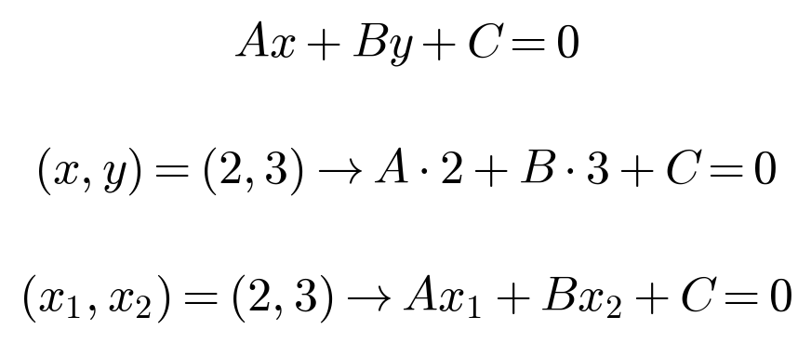

Let A = W1, B = W2 and C = W0, so eqn becomes ∴
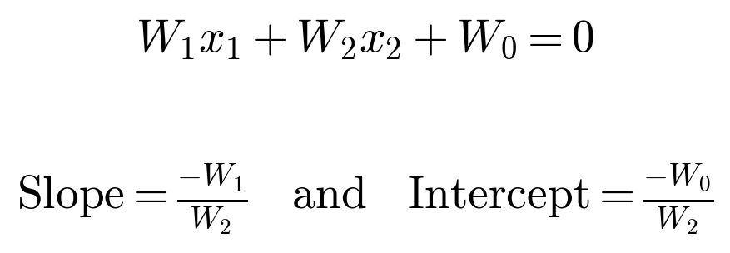

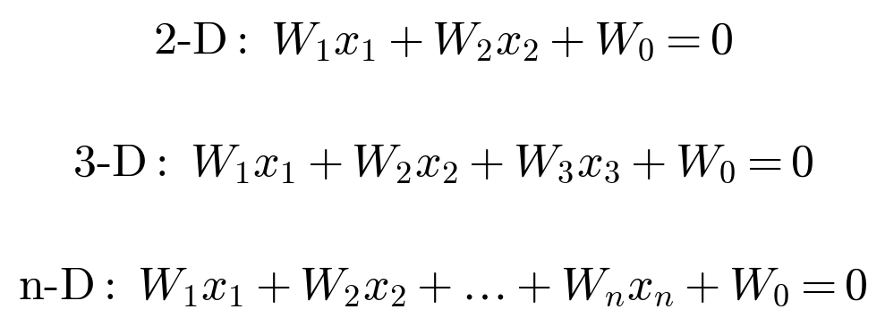

Suggestion
- "(x, y) = (2, 3) → A·2 + B·3 + C = 0" means: a point that lies on the line must satisfy the equation, so we can put its coordinates in the equation.
- Names: in 2-D the equation gives a line, in 3-D a plane, and in n-D a hyperplane (a flat surface that splits the space into two sides).
- W1, W2, …, Wn are the weights (one for each feature) and W0 is the bias / intercept (constant term).
- Slope check: from W1x1 + W2x2 + W0 = 0 we get x2 = (−W1/W2)x1 − W0/W2; so the slope is −W1/W2 and the intercept is −W0/W2.
Top of the page (cut in the binding): the text there is only partly visible. It reads roughly: "... this in the end. ... and all W's are packed in WT and hence WT also tilts the line. W0 moves line upward and downward which intercept = −W0/W2 ... and since W0 is the part of the eqn it moves / changes the line upward and downward."
Suggested completion: It continues page 13. In W1x1 + W2x2 + W0 = 0: the weights W1, W2 decide the tilt (slope) of the line, and all weights together are packed into the vector W (so WT tilts the line). The bias W0 decides the intercept, i.e. it moves the line up and down without changing its tilt. The details of the vector form come next on this page.

Notebook page 14

⇒ Convert into vector form:
• Vector W and vector X:
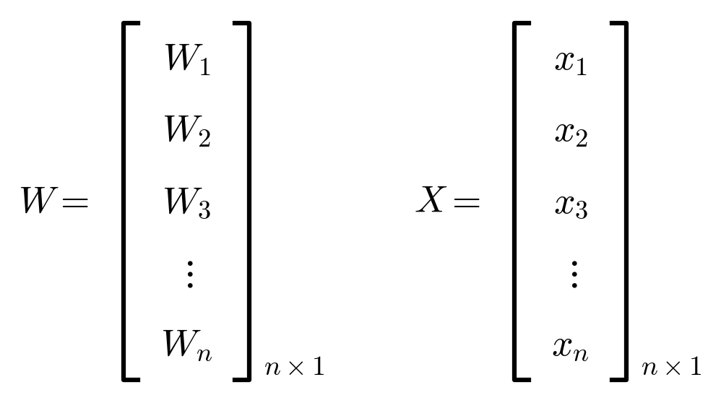
• Here dot product is not possible because shape of W = n×1 and X = n×1, where no. of columns of W and no. of rows of X are not same. Therefore we transpose W.
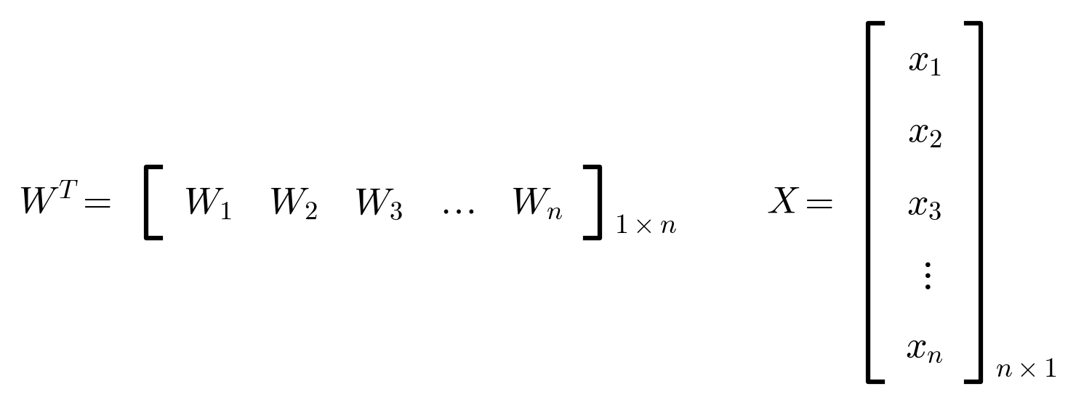

∴
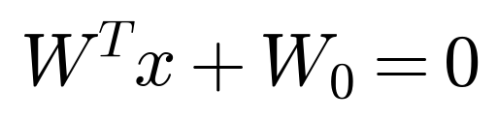

Applicable to N-D data.

Tip: In W1x1 + W2x2 + … + Wnxn + W0 = 0, W represents weights for each feature i.e. x1, x2, xn. X represents features of the data and W0 is bias term (constant).
• W0 is also an intercept.
Ax + By + C = 0 converted to W1x1 + W2x2 + W0 = 0
– W1 = A = Weight of feature x or x1
– W2 = B = Weight of feature y or x2
– W0 = C = Intercept / Bias (constant term) because we rearranged y = mx + c to Ax + By + C.
– Originally,
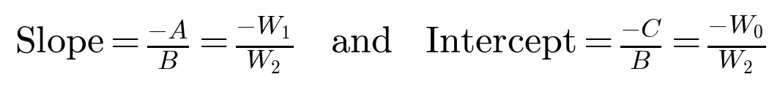

– As we rearranged the eqn y = mx + c, we get weight of y = (−1) or (1) and hence C = intercept. But regression line's eqn was always y = mx + c.

Suggestion
- Shape check: WT is (1×n) and X is (n×1), so WTX is (1×1), a single number. Then WTX + W0 = 0 is the whole hyperplane equation in one line.
- Many books write the same equation as w·x + b = 0 (b = bias). The sign of WTX + W0 tells on which side of the hyperplane a point lies: positive on one side, negative on the other. This is used in classification.
- The last bullet says: when we write y = mx + c as mx − y + c = 0, the weight of y is −1 (or +1 if we multiply the equation by −1). The constant C is still the intercept term.

